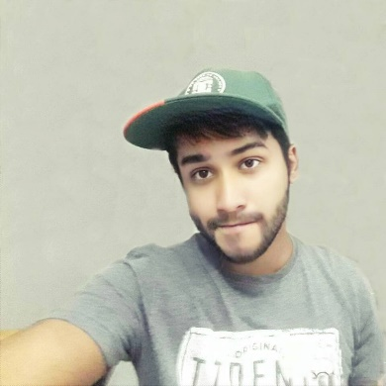

**Baizid MD Ashadzzaman**



www.linkedin.com/in/zamanAsad



ashad0167@gmail.com.com

Engineer



8801676577631

**ABOUT ME**

**WORK EXPERIENCE**  
3 Years

I want to build up my career in web design & development through research-oriented activities with PHP and Laravel. I have 2 years learning experience in PHP and Laravel .I would like to share my skills and knowledge’s to deliver value added results to the organization.

**AGE**  
23



**Education**

**BSC in Computer Science & Engineering** Graduate, 2018   
International Islamic University,

Chittagong, Bangladesh.

**Higher Secondary Certificate** Graduated, 2013Chattogram Biggan Collage,   
Chittagong, Bangladesh.

**School Secondary certificate** Graduated, 2011Bangladesh Railway Govt high School,   
Chittagong, Bangladesh.



**Technical Skills**

**Programing Language:**

C/C++, JavaScript , PHP and MySQL, Basic Java,

**Frameworks:**

Bootstrap and Laravel , Wordpress

**Tools:**

JetBrains PhpStorm 2017, Eclipse, CodeBlock, Git/GitHub., Adobe Illustrator

**Paradigms:**

Object-oriented Programming (OOP), AJAX, Agile Software Development.

**Platforms:**

Web Design / Web Development, Graphics Design



**Professional Skills**

* Communications(80%)
* Confidence(99%)
* Presentation skills(85%)
* Responsible(99%)
* Leadership(90%)



**Work Experience**

2017 – 2018  
**Trainee**   
BASIS(BITM) in Chittagong Branch  
Chittagong, Banglasehd

* Web Apps Development PHP.



**Computer Proficiency**

* Word
* Excel
* Power Point



**Languages**

* Bangla
* Hindi
* English



**Personal Interests**

|  |  |
| --- | --- |
| * Traveling | * Gardening |
| * Watching Movies | * Reading Books |
|  |  |



**Personal Details**

* NID No : 19961592812000019
* Date of Birth : 01 August 1996
* Father’s Name: Hazi MD Jahangir Alam
* Mother’s Name: Sayera Khatun
* Marital Single
* Birthday: August 01, 1996
* Nationality: Bangladeshi
* Gender: Male

# Declaration

I, Baizid MD Ashadzzaman, hereby declare that the information contained herein is true and correct to the best of my knowledge and belief.



____________________________  
Baizid MD Ashadzzmana